Assignment 11

1.
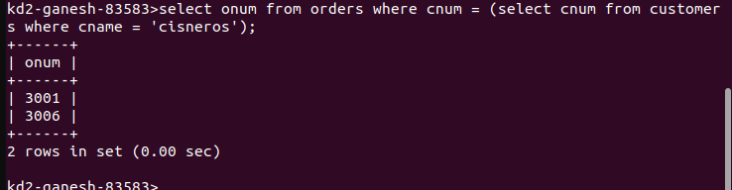
2.

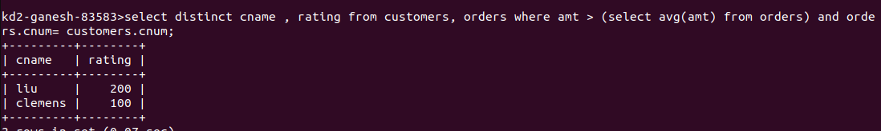
3.

